ADDING COLORS FOR LINE ITEMS VIA GLOBAL CHANGES

NOTE: COLOR SELECTIONS WILL ABORT IF A COLOR CHOICE IS SELECTED THAT IS NOT AVAILABLE FOR THE PRODUCT, OR IF THE PRODUCT IS TO BE STANDARD COLOR AND CHAMELEON COLOR IS SELECTED, OR IF THE PRODUCT IS TO BE A CHAMELEON COLOR AND A STANDARD COLOR IS SELECTED.

STEP 1 – REVIEW LINE ITEM SCREEN TO SEE IF COLORS HAVE BEEN SELECTED:

THIS WILL HOLD TRUE FOR YOUR OWN QUOTATIONS, AS WELL AS THOSE FROM THE FACTORY.

STEP 2 – SELECT GLOBAL CHANGES LINK

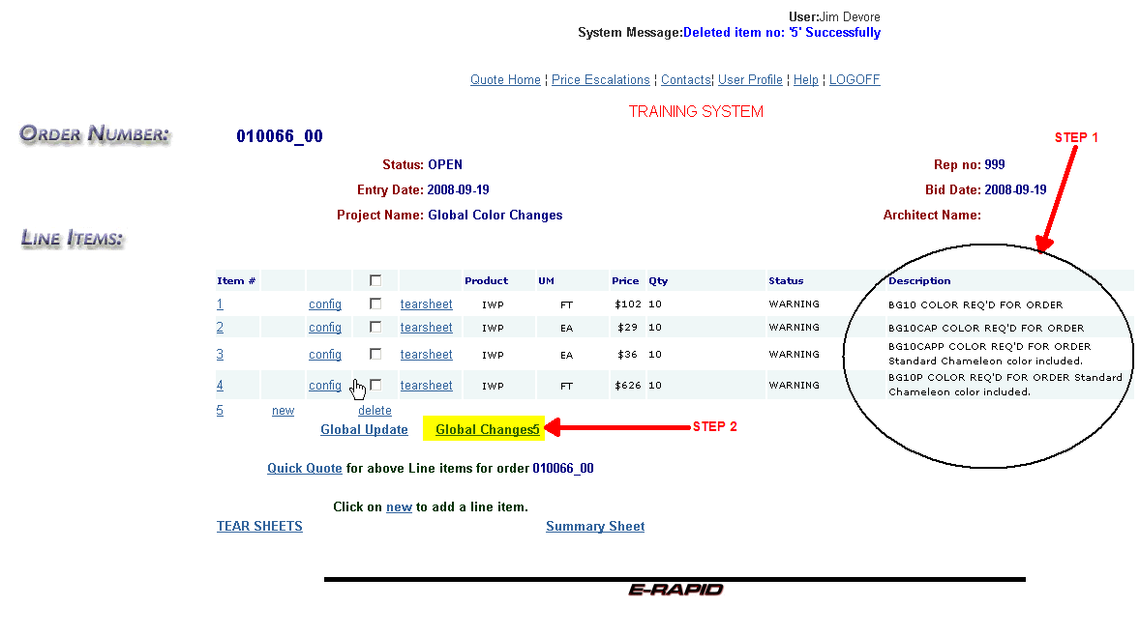

GLOBAL CHANGE SCREEN

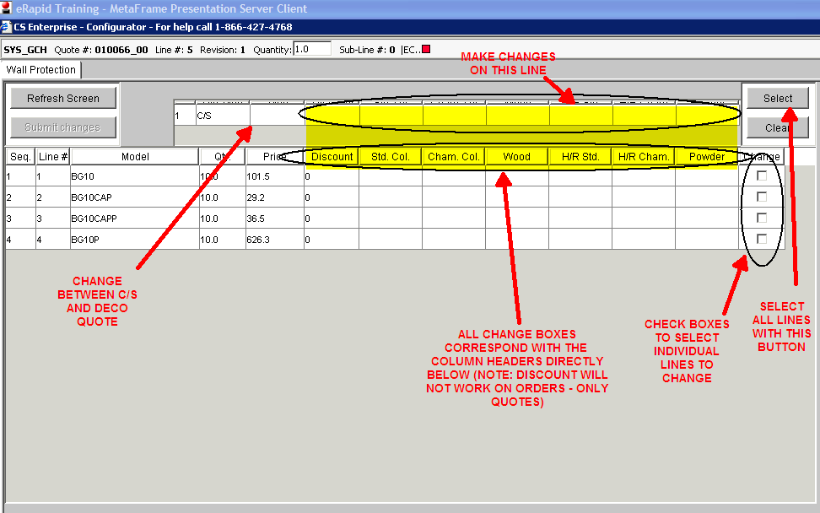

STEP 3: SELECT LINES AND MAKE CHANGES ACCORDINGLY:
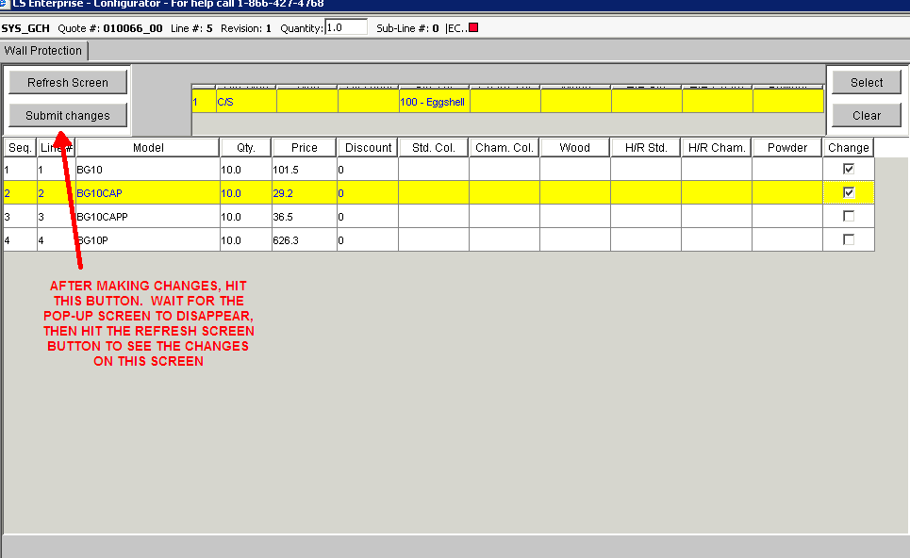
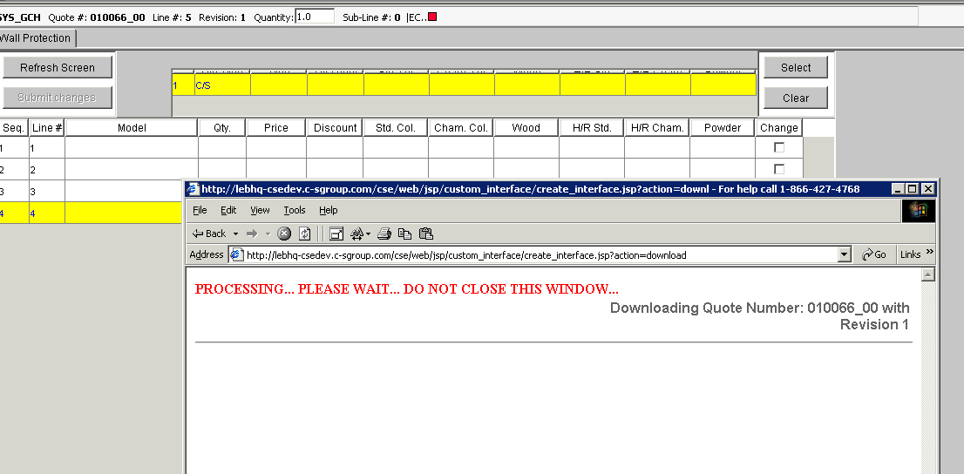

STEP 4 – REPEAT STEP 3 AS NECESSARY

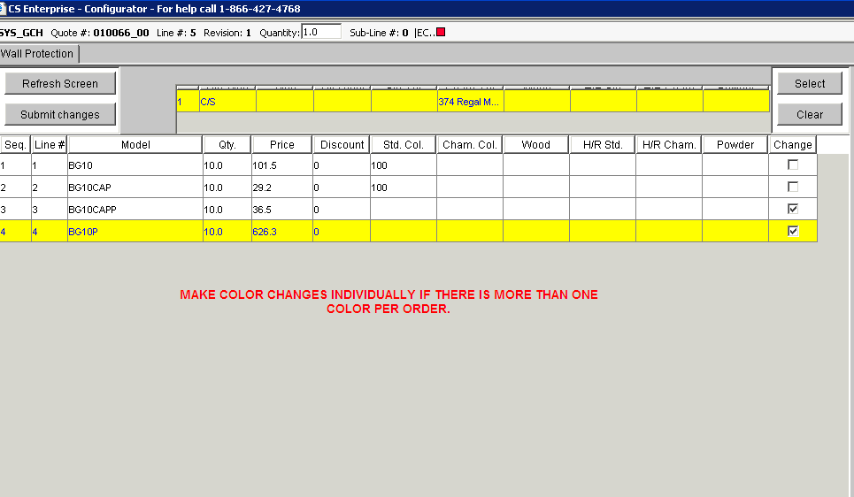

STEP 5 – WHEN FINISHED, SELECT CANCL/EXIT ON THE LOWER RIGHT.
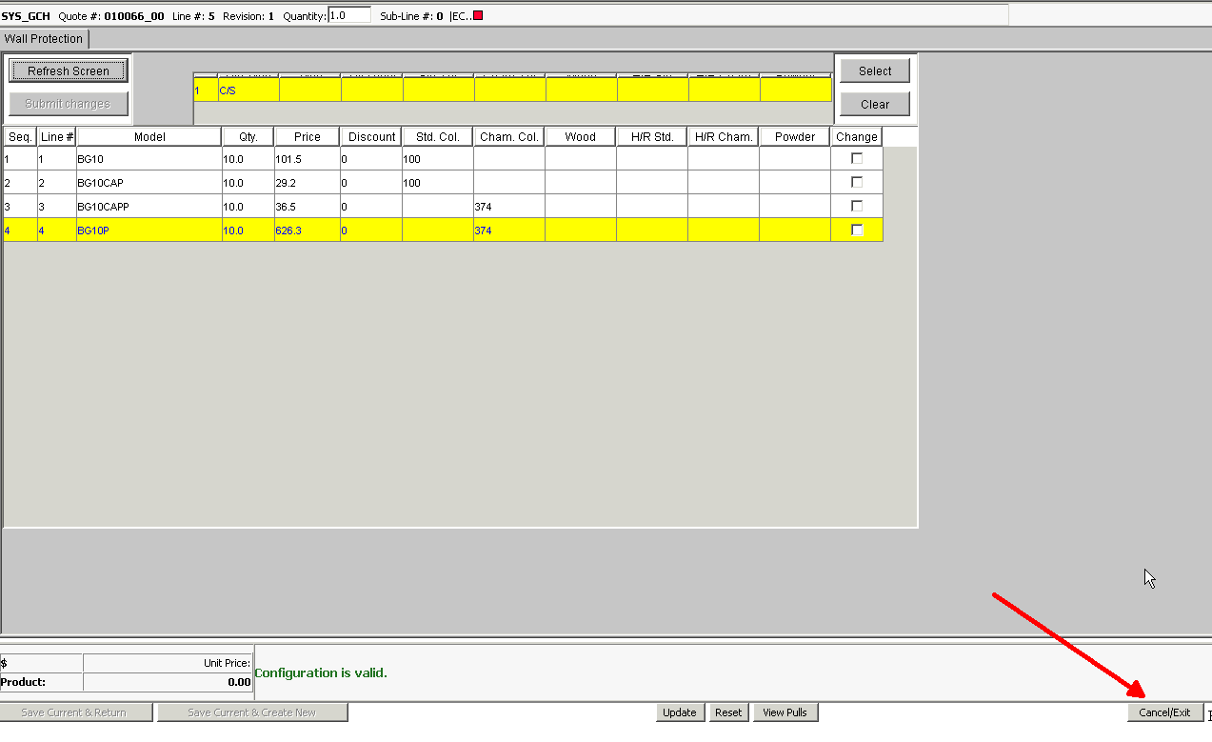
STEP 6 – REVIEW LINE ITEM SCREEN:

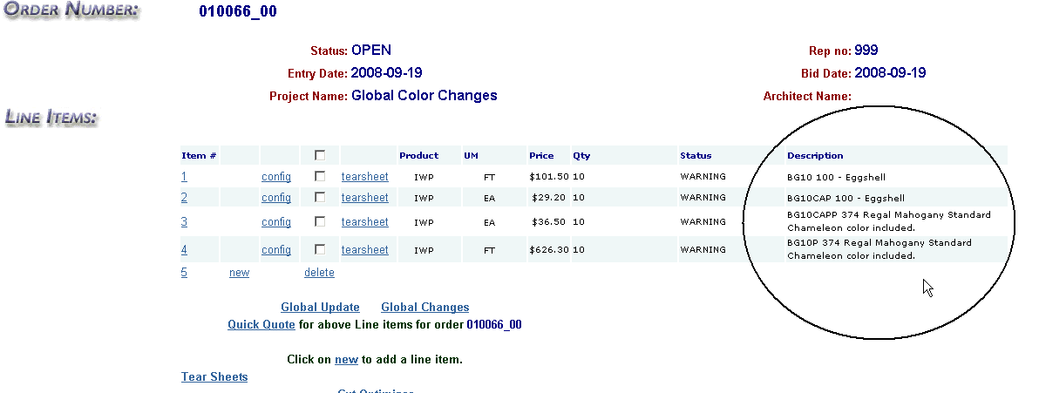

END OF INSTRUCTIONS

